January 22, 2023
9:30 AM Worship Service
Third Sunday after Epiphany

*Musical Prelude:
Welcome and Announcements

Call to Worship: Lay Reader: Lois Pettorsson
L: O God, you are our Creator and Redeemer.
P: You have called us, and we are here to listen.
L: You have sent us. We are ready and committed to give your message.
P: Teach us how to share your message, O God.
L: O God, send us where we should go.
P: O, Holy Spirit, open the hearts of those where you are sending us. Amen.

Song of Praise: He Has Made Me Glad TFWS #2270
I will enter his gates with thanksgiving in my heart,
I will enter his courts with praise.
I will say, “This is the day that the Lord has made.”
I will rejoice, for he has made me glad.

Refrain: He has made me glad, he has made me glad.
I will rejoice, for he has made me glad.
He has made me glad, he has made me glad.
I will rejoice, for he has made me glad.

Opening Prayer:
Almighty God, we are here today to obey your command to go and share your message. Give us wisdom and courage. Above all, empower us with your Holy Spirit for our labor. O God, open the spirits of those to whom you are sending us to give your message of redemption. Amen.

Opening Hymn: Come, Christians Join to Sing UMH #158
Come, Christians, join to sing: Alleluia! Amen!
Loud praise to Christ our King: Alleluia! Amen!
Let all, with heart and voice, before His throne rejoice;
Praise is His gracious choice. Alleluia! Amen!

Come, lift your hearts on high: Alleluia! Amen!
Let praises fill the sky: Alleluia! Amen!
He is our guide and friend; to us he’ll condescend;
His love shall never end: Alleluia! Amen!

Praise yet the Lord again: Alleluia! Amen!
Life shall not end the strain: Alleluia! Amen!
On heaven’s blissful shore his goodness we’ll adore,
Singing forevermore: Alleluia! Amen!

Affirmation of Faith: The Apostles’ Creed UMH 881
I believe in God, the Father Almighty, maker of heaven and earth;
And in Jesus Christ his only Son, our Lord; who was conceived by
the Holy Spirit, born of the Virgin Mary, suffered under Pontius Pilate, was crucified, dead, and buried;* the third day he rose from the dead; he ascended into heaven, and sitteth at the right hand of God the Father Almighty; from thence he shall come to judge the quick and the dead. I believe in the Holy Spirit, the universal church,
the communion of saints, the forgiveness of sins, the resurrection
of the body, and the life everlasting. Amen.

Passing of the Peace
Wiggle Time/Noisy Coins/ Offering

Doxology UMH #95

Offertory Prayer:
Messiah, we admit that we struggle to deny ourselves, take up our cross, and follow you. It is hard to let go of the human things that make us feel secure. Help us to set our minds on divine things. Today, we give over our offering to you, trusting that you not only give us life, but that you can and will use our gifts to bring life to the world. Amen.

Prayer Chorus: Cares Chorus TFWS #2215
I cast all my cares upon you, I lay all of my burdens down at your feet,
And anytime that I don’t know what to do, I will cast all my cares upon you.

Pastoral Prayer:
The Lord’s Prayer:

Hymn of Preparation: O Master, Let Me Walk with Thee UMH #430
O Master, let me walk with thee in lowly paths of service free;
Tell me thy secret; help me bear the strain of toil, the fret of care.

Help me the slow of heart to move by some clear, winning word of love;
Teach me the wayward feet to stay, and guide them in the homeward way.

Teach me thy patience; still with thee in closer, dearer company,
In work that keeps faith sweet and strong, in trust that triumphs over wrong;

In hope that sends a shining ray far down the future’s broadening way,
In peace that only thou canst give, with thee, O Master, let me live.

Scripture: Mark 8:27-38
Sermon: “Are You Sure You’re Up for This?” Rev. Karen Murray

Closing Hymn: I Am Thine, O Lord UMH #419
I am thine, O Lord, I have heard thy voice, and it told thy love to me;
But I long to rise in the arms of faith and be closer drawn to thee.

Refrain: Draw me nearer, nearer, blessed Lord, to the cross where thou hast died.
Draw me nearer, nearer, nearer, blessed Lord, to thy precious, bleeding side.

Consecrate me now to thy service, Lord, by the power of grace divine;
Let my soul look up with a steadfast hope, and my will be lost in thine. Refrain:

O the pure delight of a single hour that before thy throne I spend,
When I kneel in prayer, and with thee, my God, I commune as friend with friend! Refrain:

There are depths of love that I cannot know till I cross the narrow sea;
There are heights of joy that I may not reach till I rest in peace with thee. Refrain:

Benediction

Sending Forth: Go In Love
Go in love. Have no fear, God will guide you, He is always near.
Go in love. Take his hand. God will hear you, He will understand.
May his light forever shine upon you; May his peace be always in your heart.
Go in love, face each day. God will lead you, He will show the way.
Go in love and live in faith. Amen.

Postlude

Last week’s offering received: $1,104.50 In person attendance last week: 44

“Our vision is to share Christ’s love with all by ministering to those in need
spiritually, emotionally, and physically with grateful hearts
as demonstrated by God’s love for us.” (1 John 4:19)
Masonville-Rancocas United Methodist Church
200 Masonville Rd.
Mt. Laurel, New Jersey 08054
(856) 234-0941

"We are a Christ-Centered Church reaching out to the world transforming lives for the Glory of God.”

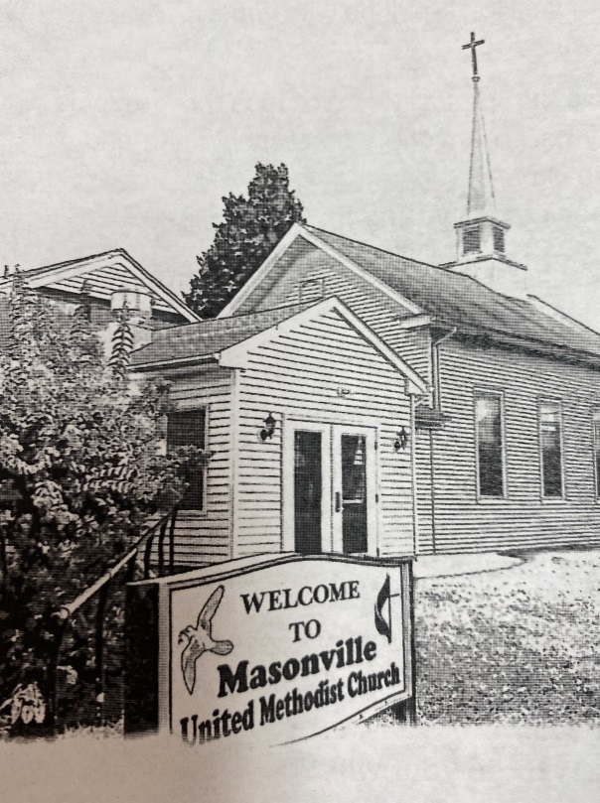

Rev. Karen Murray, Pastor
Cell # 856-266-0083

Mike Gerety, Musician
Shirley Bootsma, Choir Director
Wendy Smith, Administrative Assistant

Website: www.masumc.org
Or Email: mumc07@live.com
CCLI# 13777290

