July 11, 2021
9:30 AM Worship Service
7th Sunday After Pentecost
*Musical Prelude:
Welcome and Announcements

Entrance Song: To God Be The Glory UMH #98

To God be the glory, great things he hath done!
So loved he the world he gave us his Son,
Who yielded his life an atonement for sin,
And opened the life-gate that all may go in.

Refrain: Praise the Lord, praise the Lord, let the earth hear his voice!
Praise the Lord, praise the Lord, let the people rejoice!
O come to the Father thru Jesus the Son,
And give him the glory, great things he hath done!

O perfect redemption, the purchase of blood,
To every believer the promise of God;
The vilest offender who truly believes,
That moment from Jesus a pardon receives. Refrain:

Great things he hath taught us, great things he hath done,
And great our rejoicing thru Jesus the Son;
But purer, and higher, and greater will be our wonder,
Our transport, when Jesus we see. Refrain:

Call to Worship:

L: The earth is the Lord’s! Everything in creation belongs to God.
P: Lift up your eyes! See the mighty works of the Lord!
L: This is the Lord’s house! All who hope in the Lord will be called children of God.
P: Lift up your hearts! Receive the gracious gifts of the Lord!
L: This is the hour for worship and song.
P: Lift up your voice! Praise the Lord with all your might!

Song of Praise: I Sing Praises to Your Name TFWS #2037

I sing praises to your name, O Lord, praises to your name, O Lord,
For your name is great and greatly to be praised.

I give glory to your name, O Lord, glory to your name, O Lord,
For your name is great and greatly to be praised.

Opening Prayer:
God of all creation, everything that you have made lifts its unique voice to praise you in all of your glory. Even as we worship here, we join our voices to the one true song — the song the morning stars began, the song King David danced, the song the angels echoed at the birth of your Son. Glory to you, Holy God! Glory! Let this hour of worship be wholly to the praise of your glory. Amen.

Opening Hymn: Blessed Assurance UMH #369

Blessed assurance, Jesus is mine! O what a foretaste of glory divine!
Heir of salvation, purchase of God, born of his spirit, washed in his blood.

Refrain: This is my story, this is my song, praising my Savior all the day long; This is my story, this is my song, praising my Savior all the day long.

Perfect submission, perfect delight, visions of rapture now burst on my sight;
Angels descending bring from above echoes of mercy, whispers of love. Refrain:

Perfect submission, all is at rest; I in my Savior am happy and blest,
Watching and waiting, looking above, filled with his goodness, lost in his love. Refrain:

Affirmation of Faith: Apostle’s Creed (See Insert) UMH #881

Passing of the Peace
Wiggle Time/Noisy Coins/ Offering
Offertory Prayer

Prayer Chorus: Lead Me, Lord UMH #473

Lead me, Lord, lead me in thy righteousness;
Make thy way plain before my face.
For it is thou, Lord, thou, Lord only, that makest me dwell in safety.

Pastoral Prayer:

Scripture: 2 Samuel 6:1-5, 12b-19 and Ephesians 1:3-14
Sermon: “The Power of Praise!” Karen M. Murray

Hymn of Preparation: Let Us Break Bread Together UMH #618

Let us break bread together on our knees, (on our knees)
Let us break bread together on our knees. (on our knees)
When I fall on my knees with my face to the rising sun,
O Lord, have mercy on me. (on me)

Let us drink wine together on our knees, (on our knees)
Let us drink wine together on our knees. (on our knees)
When I fall on my knees with my face to the rising sun,
O Lord, have mercy on me. (on me)

Let us praise God together on our knees, (on our knees)
Let us praise God together on our knees. (on our knees)
When I fall on my knees with my face to the rising sun,
O Lord, have mercy on me. (on me)
Communion: (See Insert) UMH #13

Closing Hymn: Sent Forth by God’s Blessing UMH #664
Sent forth by God’s blessing, our true faith confessing,
The people of God from this dwelling take leave.
The service is ended, O now be extended the fruits of our worship in all who believe.
The seed of the teaching, receptive souls reaching,
Shall blossom in action for God and for all.
God’s grace did invite us, and love shall unite us to work for God’s kingdom and answer the call.

With praise and thanksgiving to God ever living,
The tasks of our everyday life we will face.
Our faith ever sharing, in love ever caring, embracing God’s children of each tribe and race.
With your grace you feed us, with your light now lead us;
Unite us as one in this life that we share.
Then may all the living with praise and thanksgiving give honor to Christ and that name which we bear.

Benediction
Sending Forth: Go In Love
Go in love. Have no fear, God will guide you, He is always near.
Take his hand. God will hear you, He will understand.
May his light forever shine upon you; May his peace be always in your heart.
Go in love. Face each day. God will lead you, He will show the way.
Go in love and live in faith. Amen.
Postlude

Last week’s offering received: $1,185.00
In person attendance last week: 31

“Our vision is to share Christ’s love with all by ministering to those in need
spiritually, emotionally, and physically with grateful hearts
as demonstrated by God’s love for us.”(1 John 4:19)
Masonville-Rancocas United Methodist Church
200 Masonville Rd.
Mt. Laurel, New Jersey 08054
(856) 234-0941

"We are a Christ-Centered Church reaching out to the world transforming lives for the Glory of God.”

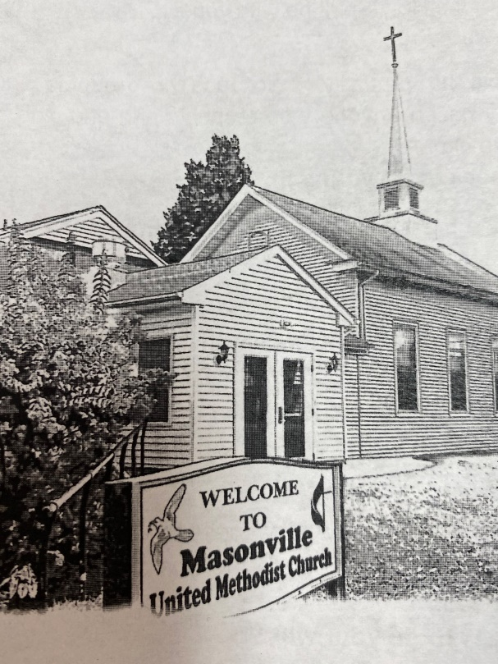
Rev. Karen Murray, Pastor

Mike Gerety, Musician
Shirley Bootsma, Choir Director
Wendy Smith, Administrative Assistant

Website: www.masumc.org
Or Email: mumc07@live.com
CCLI# 1377729

